Storage Area 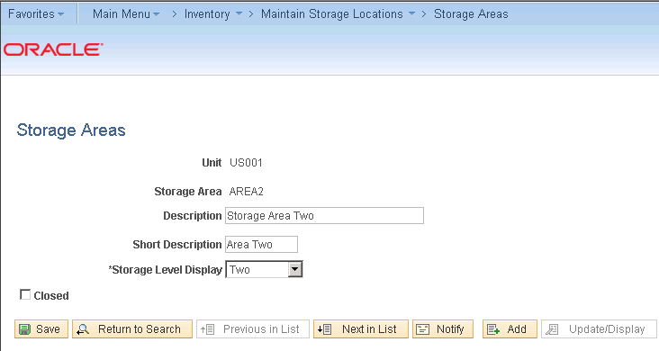

Material Storage Location 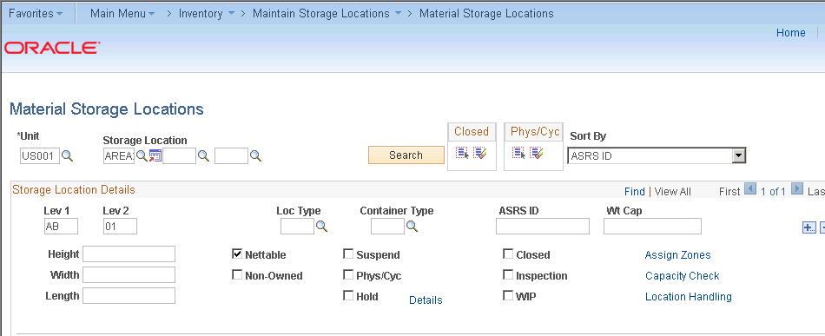

Default Putaway Location 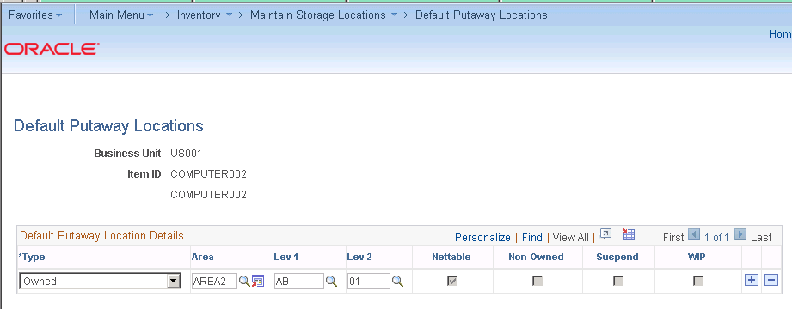

Fixed Picking location 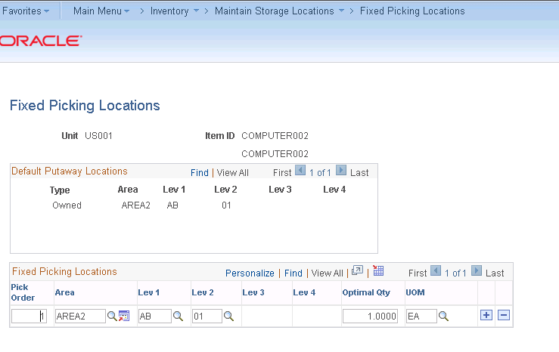

Created a Receipt id for PO 264 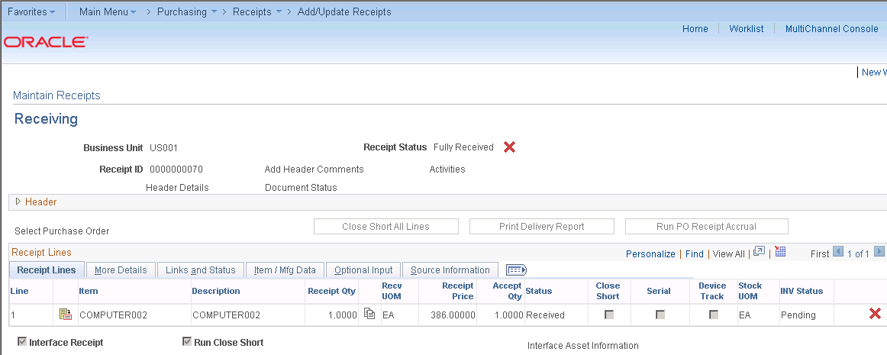

At the time of saving the receipt RECV_01 JOB is run. It consist of the following processes

PO_RECVPUSH Process (Receiver Interface Push Application Engine Process)

The Receiver Interface Push process moves data to the PeopleSoft application interface table, where it is picked up by the different batch processes.

INPSSTGE - COBOL SQL- Inventory Load Staged item process 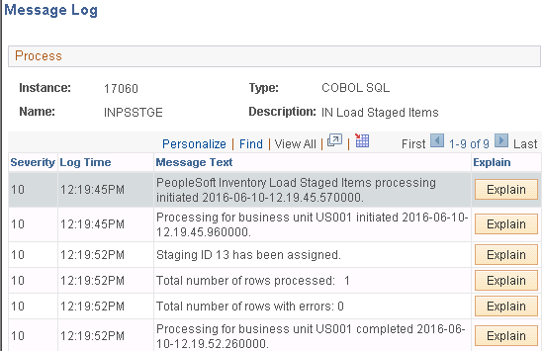

INS3500 – Inventory Putaway Plan report 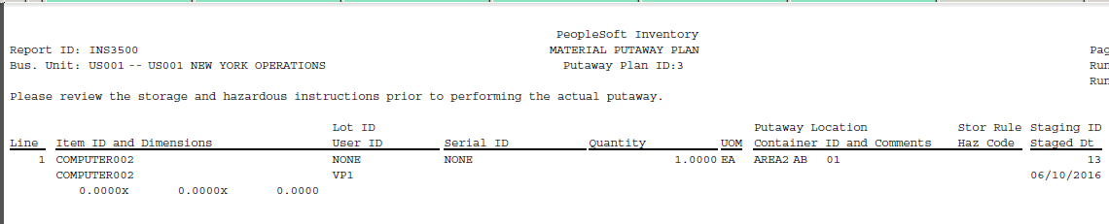

INPPPTWY – Inventory Putaway Process

* **Using the Receipt to Inventory & AM Multiprocess Job (RECV_03)**

The Receipt to Inventory & AM process processes receipts that contain inventory-related lines, asset-related lines, or lines that contain both.

The Receipt to Inventory & AM multiprocess job runs these processes automatically:

• Receiver Interface Push process.

• PeopleSoft Inventory Load Staged Items process (INPSSTGE).

• PeopleSoft Inventory Putaway Plan report (INS3500).

• PeopleSoft Inventory Putaway process (INPPPTWY).

• PeopleSoft PO/AP/AM Interface process (AMPS1000).

• PeopleSoft Asset Transaction Loader (AMIF1000).

* **Receipt Push Inventory multiprocess job (RECV_01).**

This process runs these processes automatically:

• Receiver Interface Push process.

• PeopleSoft Inventory Load Staged Items process (INPSSTGE).

• PeopleSoft Inventory Putaway Plan report (INS3500).

• PeopleSoft Inventory Putaway process (INPPPTWY).

* **Receipt Push Assets multiprocess job (RECV_02).**

This process runs these processes automatically:

• Receiver Interface Push process.

• PeopleSoft PO/AP/AM Interface process (AMPS1000).

• PeopleSoft Asset Transaction Loader (AMIF1000).

Review Transaction History for a particular BU item 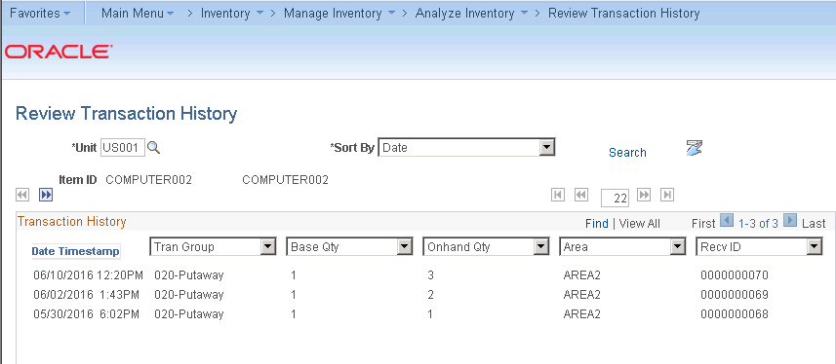

Item Balance by Unit 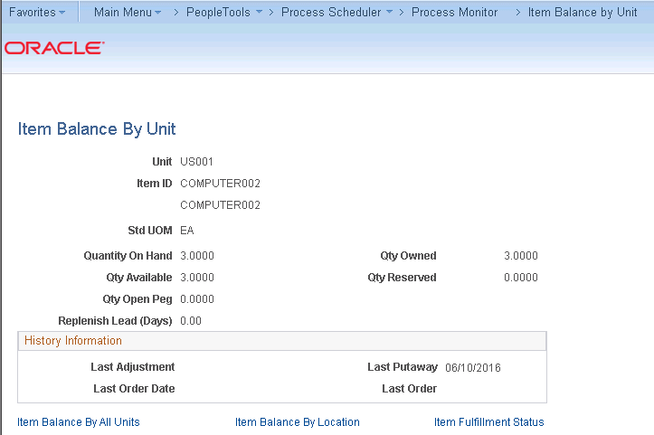

Item Balance by location 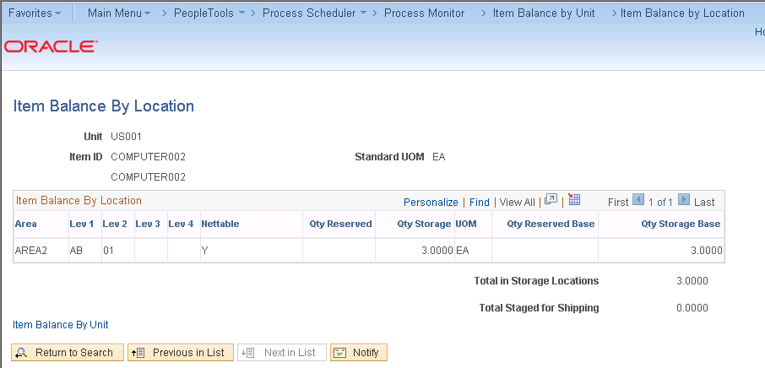

Correct Staged Errors 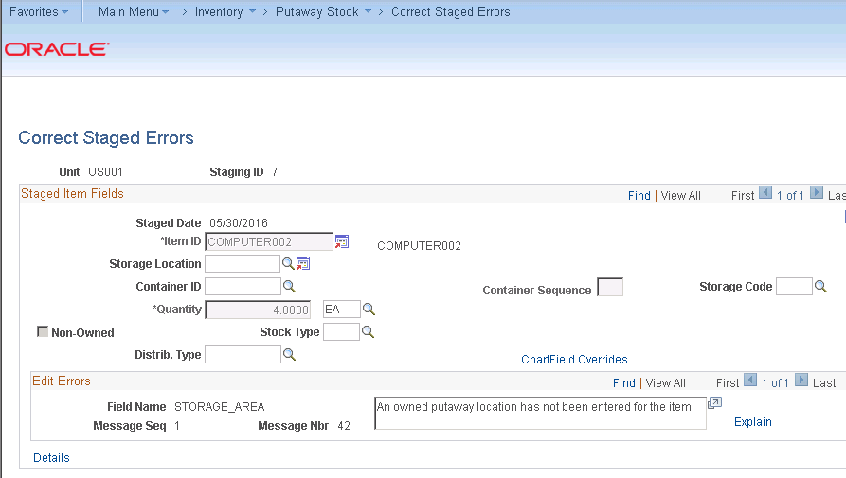

Save the staging id with the storage location 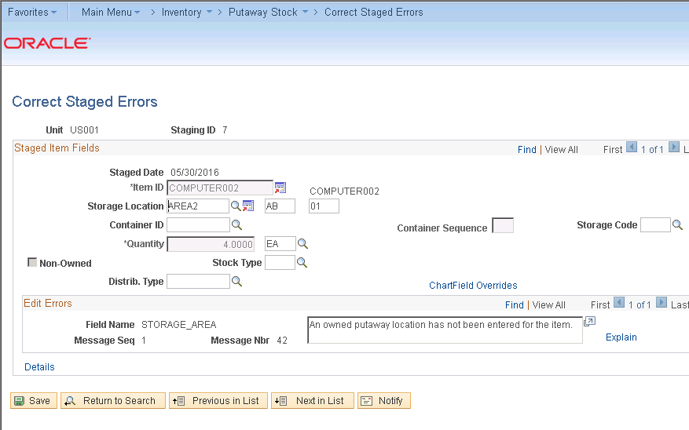

Complete Putaway 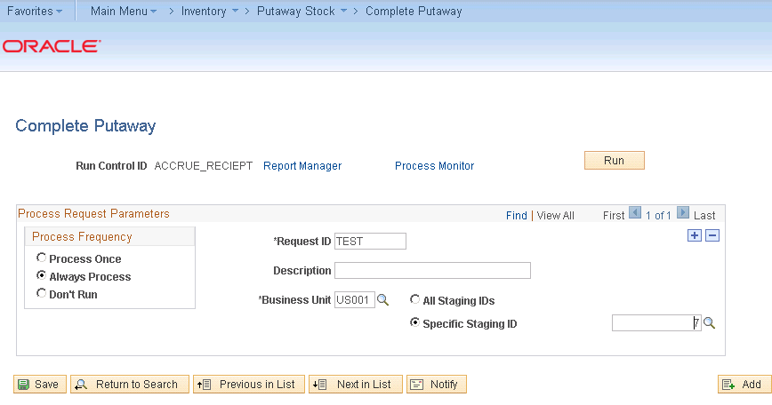

INPPPTWY process is run 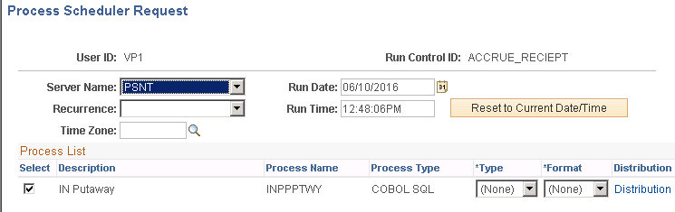

Stock has increased at BU and location level 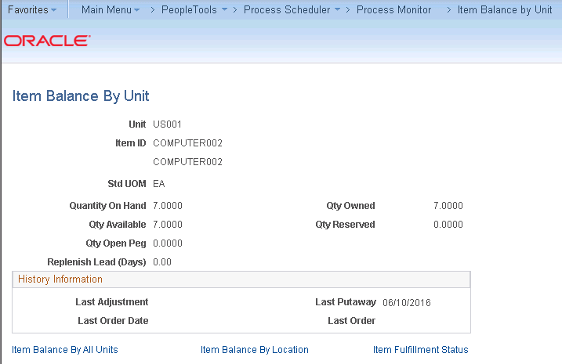

Review Transaction history 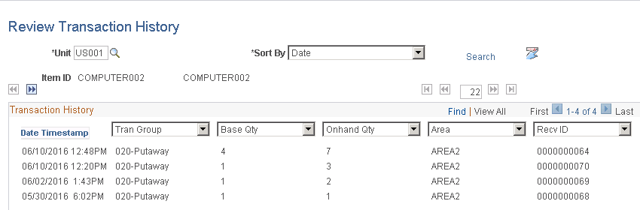

Transfer within the BU 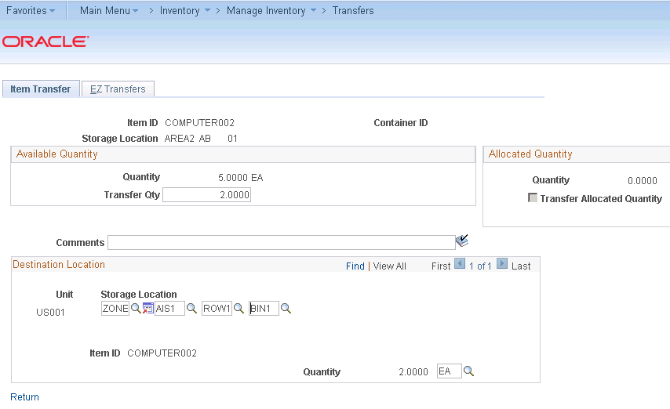

Transaction History 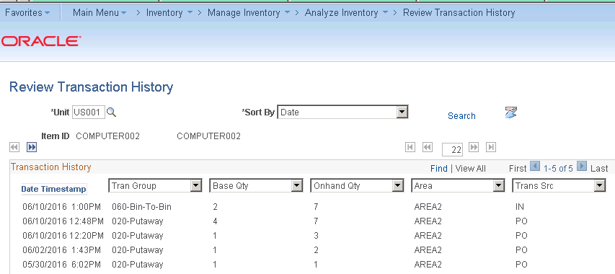

BU level there will be no change but at Physical level below are the changes 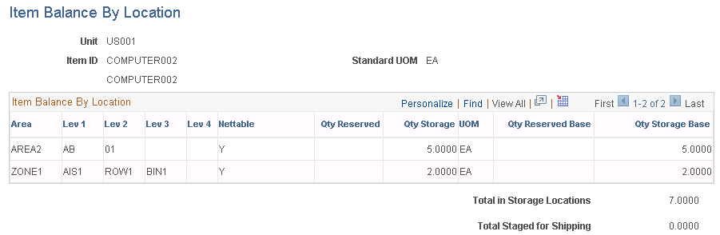

Material stock request 50 is created 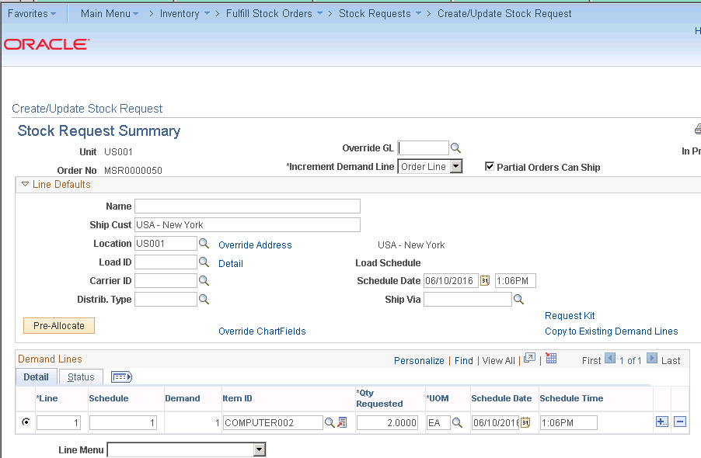

Approve Stock Request 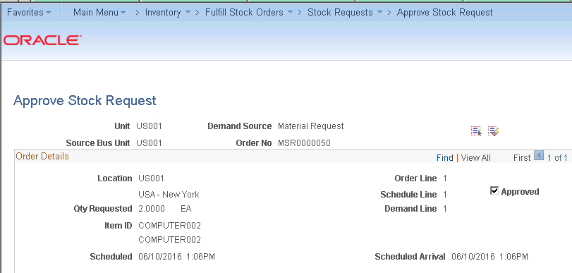

Reserve Material Process – IN_FUL_RSV process 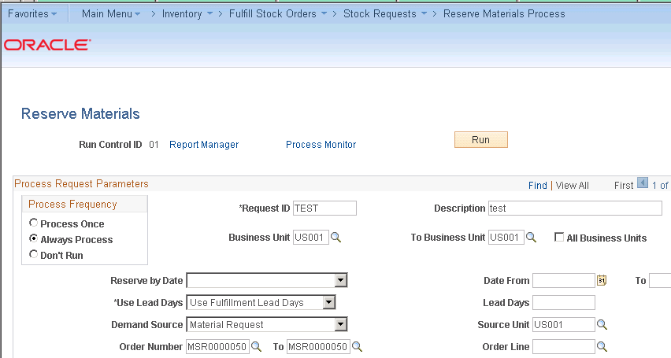

Order Release Request 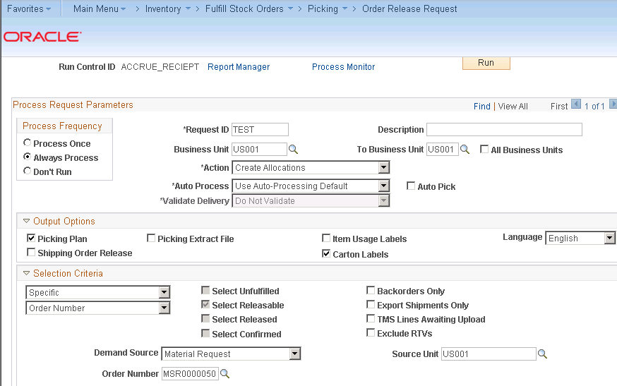

INORDRLS process is run

IN_FUL_RLS

INS6000 - Lists picking instructions for stockroom processing

INS6025 - Creates a flat file for thirdparty label printing software. These labels, which can be applied to each carton, enable you to provide shipping information for shipping personnel and carriers, build shipping containers, and provide customer-specific information identifying items within the cartons

INS6040 - Creates a flat file that you can use to produce labels that are stored with items in their par location and are placed on a charge sheet when the item is taken from the par location

PBI 4 is generated 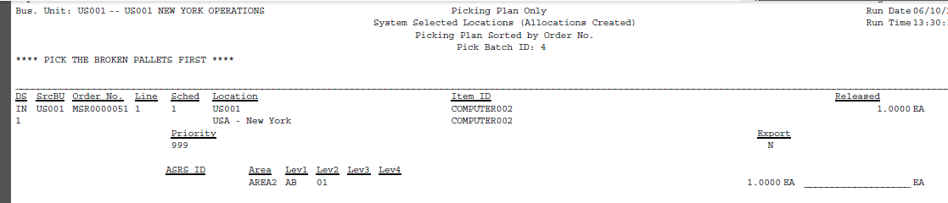

Qty gets reserved at Physical level 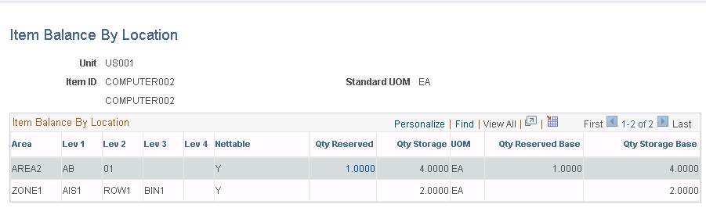

Material Picking Feedback 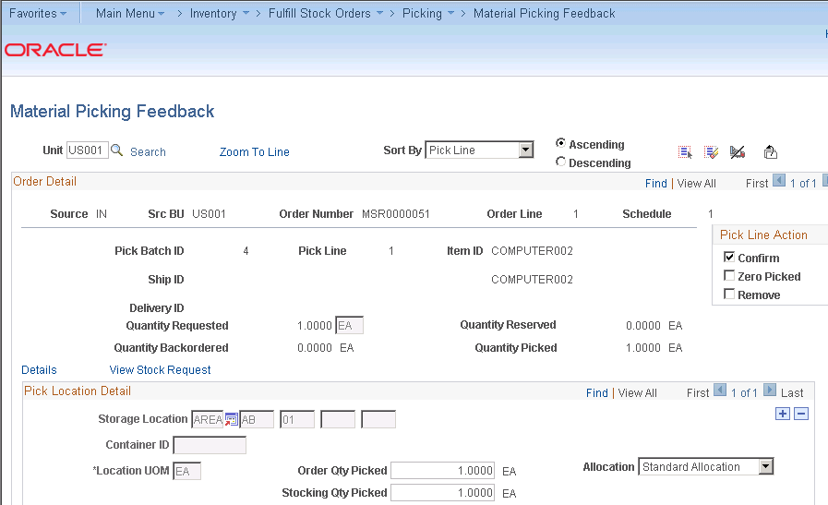

Picking Confirmation Process IN_FUL_CONF process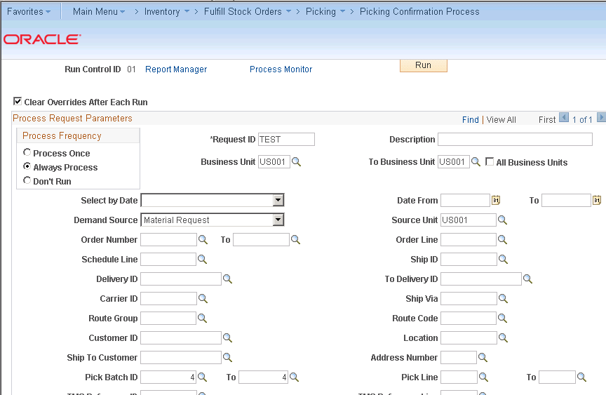

BU level 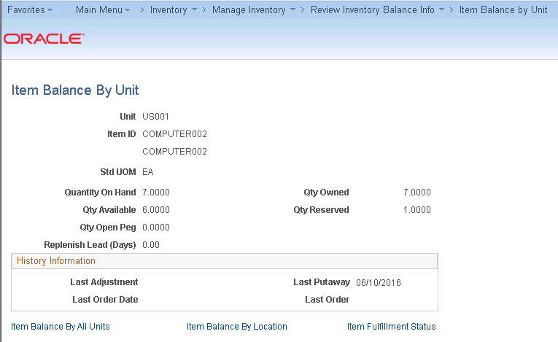

Shipping Request IN_FUL_SHP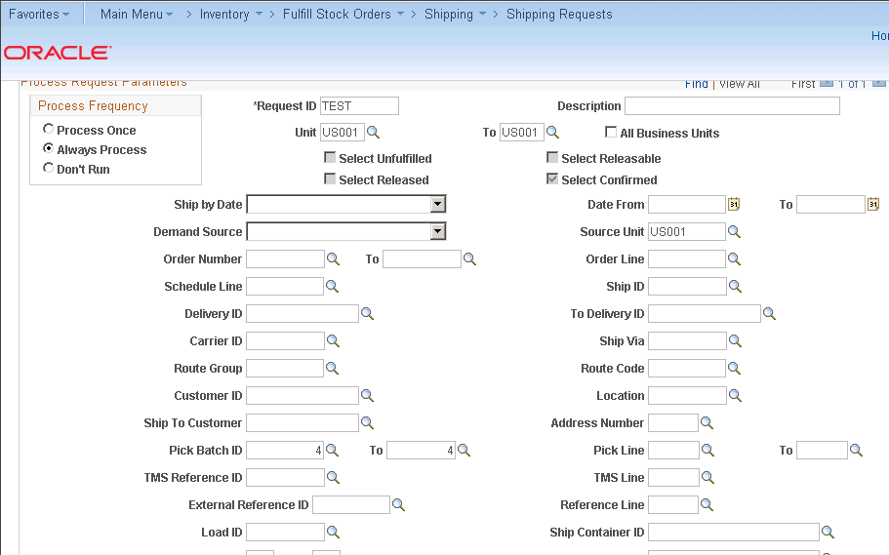

Shipping id 3 is generated 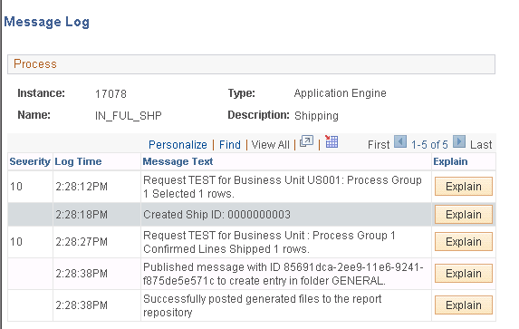

Shipping id 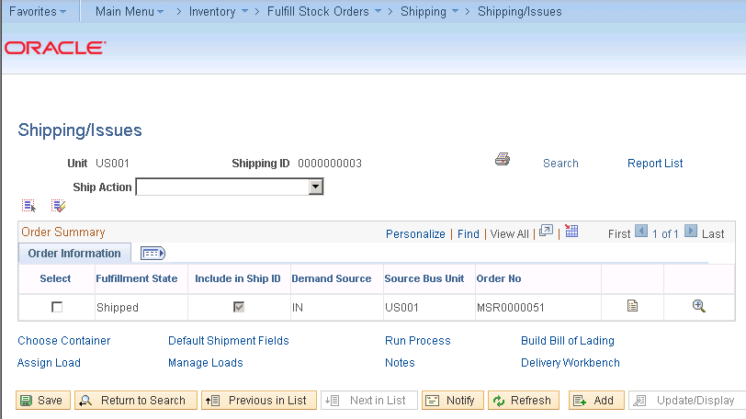

Deplete on hand quantity IN_FUL_DPL 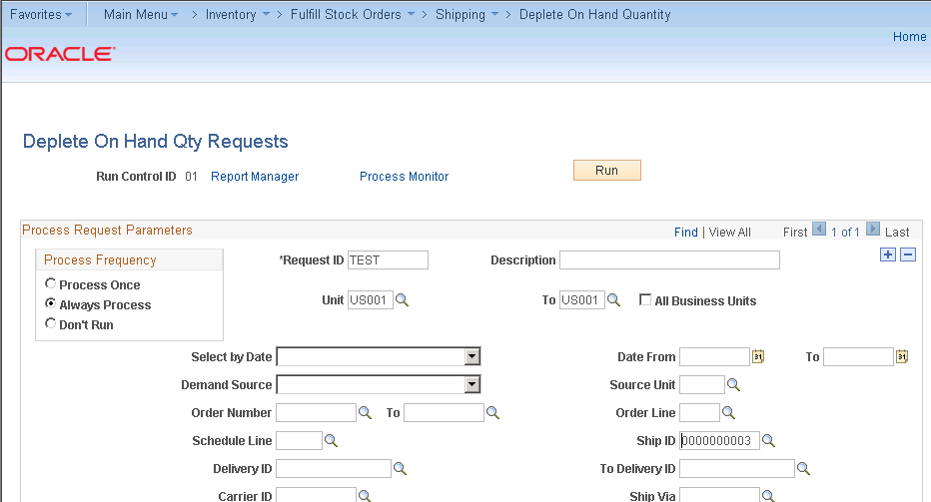

Stock gets depleted 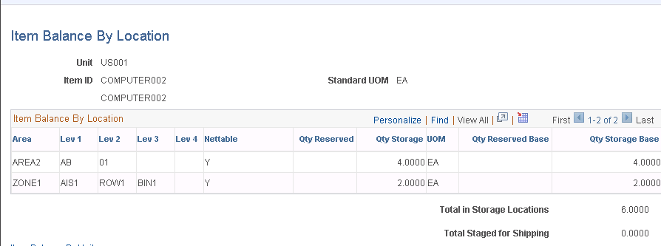

# Returned Material Authorizations

Create an RMA Document.

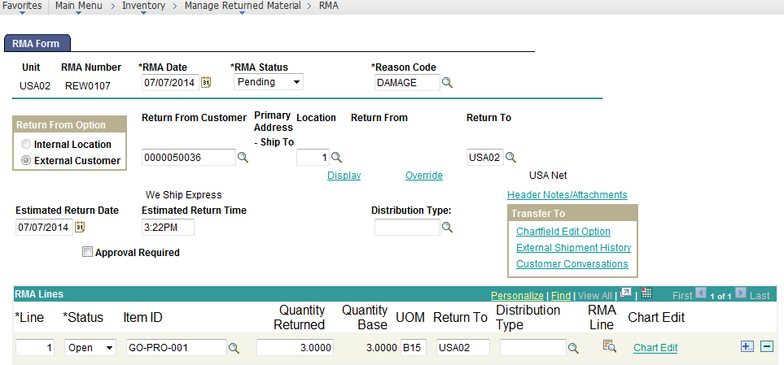

Add RMA Receipt Document.

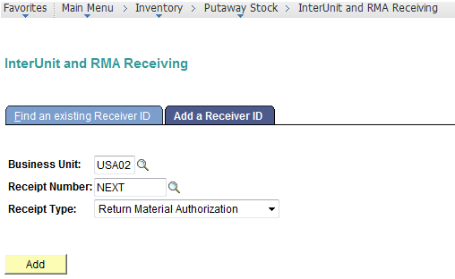

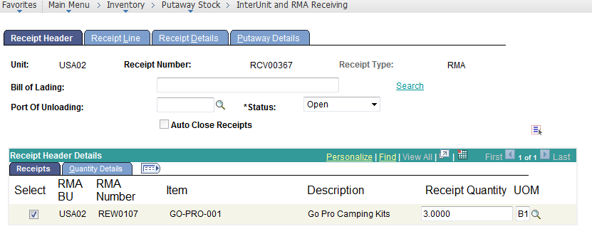

Run the Normal Putaway Processing

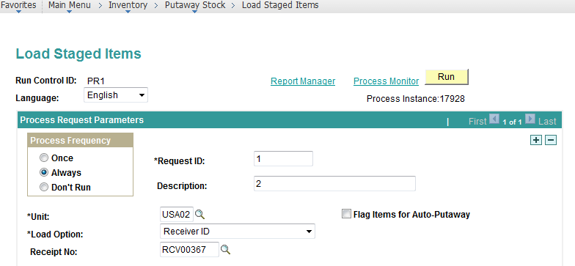

Provide the Stockroom Feedback.

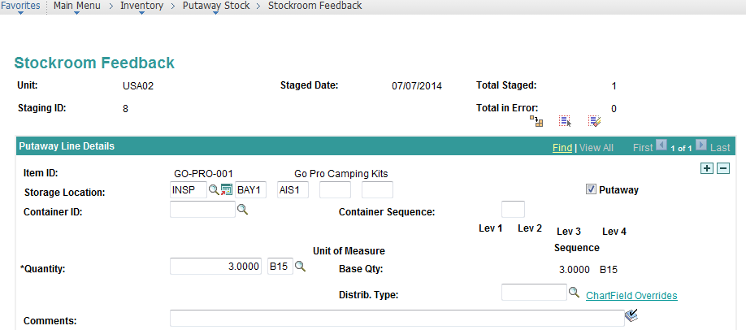

Complete Putaway:

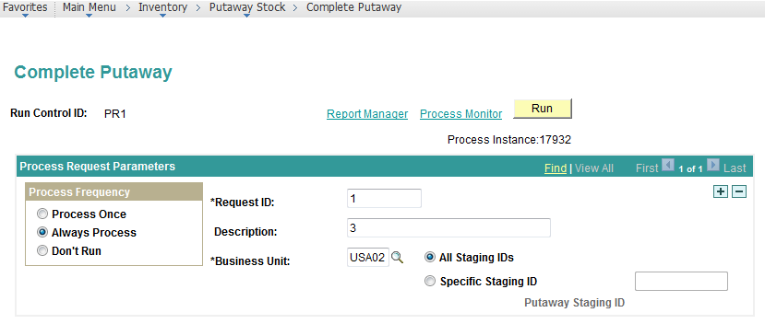

Increments the Material Available Quantity.

